My Jenkins is hosted in Amazon AWS EC2 instance.

**Jenkins Jobs**

Two continuous integration jobs set up in Jenkins in this example to poll the github repo for any change – One job to build the individual user level branches and the other one to build project/feature level branches.

There are two ways of triggering the integration jobs. Either by configuring Webhooks to trigger a Jenkins build on any branch change or by polling the SCM at regular intervals. I’ve used the polling mechanism since I have used Github as my source code repository.

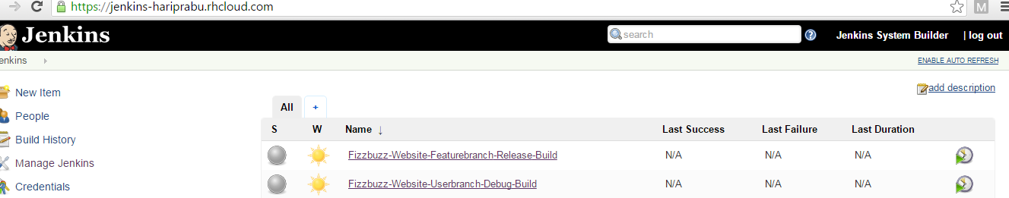

**Fizzbuzz-Website-Userbranch-Debug-Build**

This will build each individual user branch in debug mode to give instant feedback on their changes.

**Job Configuration**

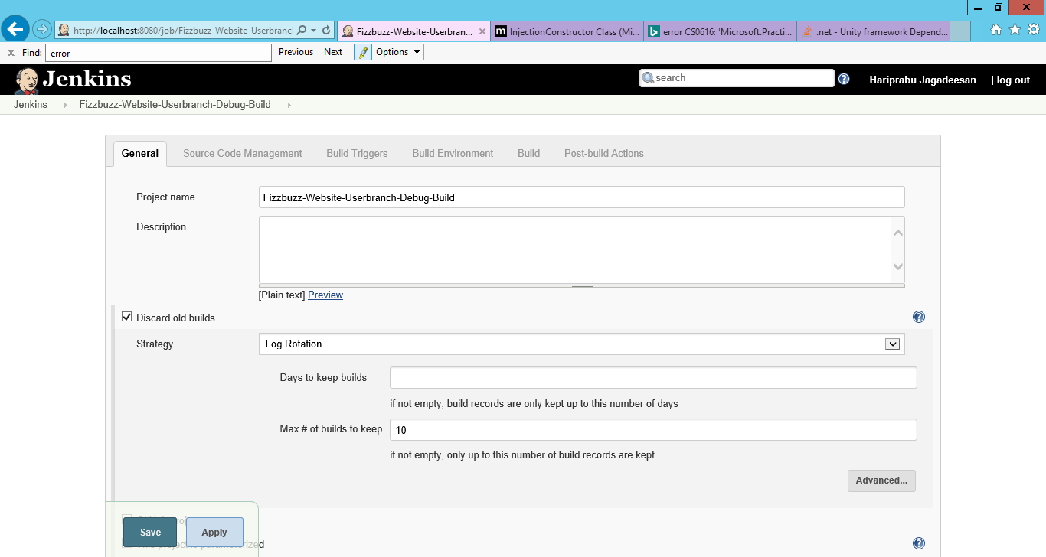

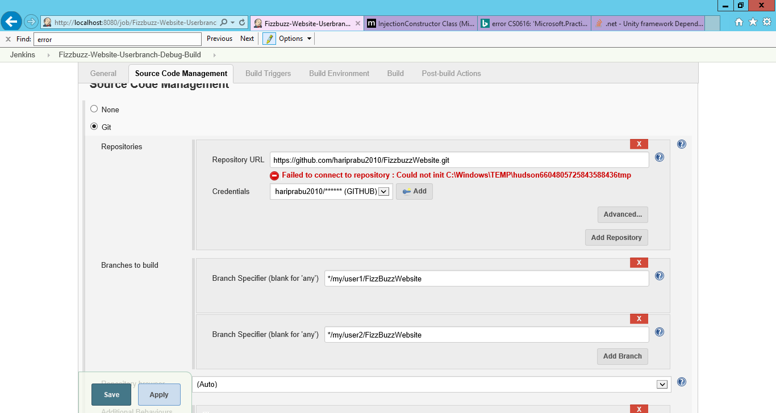

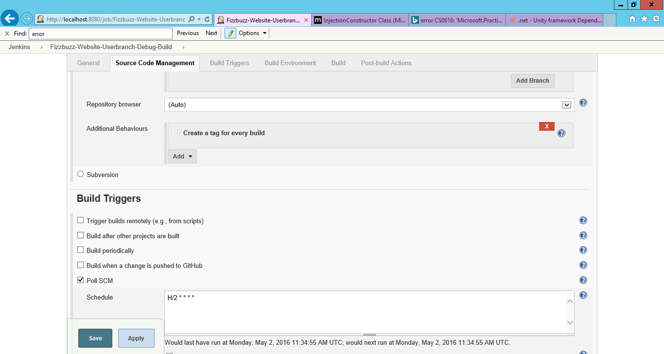

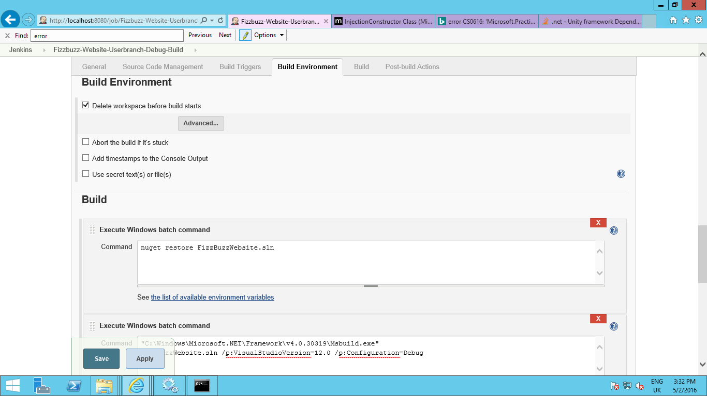

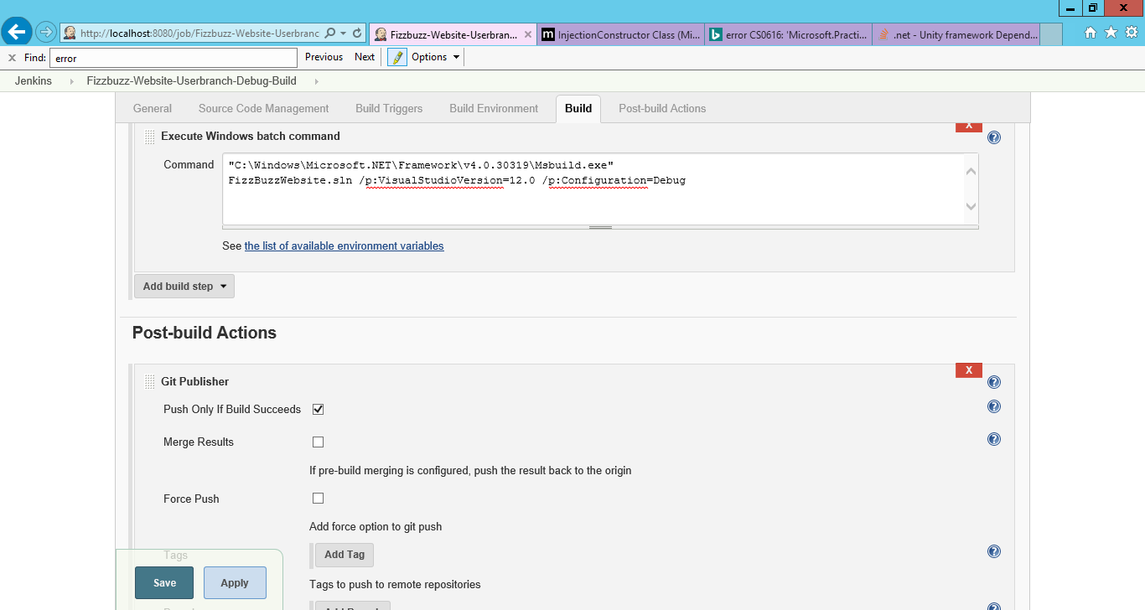

Git Polling Logs for the User branches

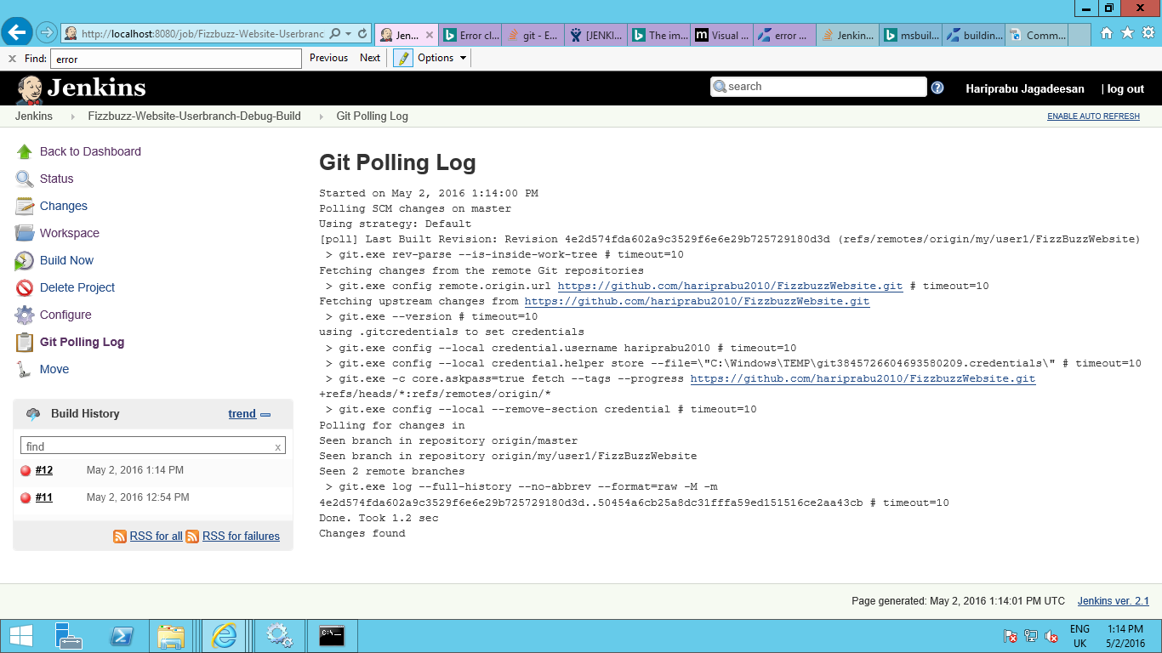

Build Status of User branches

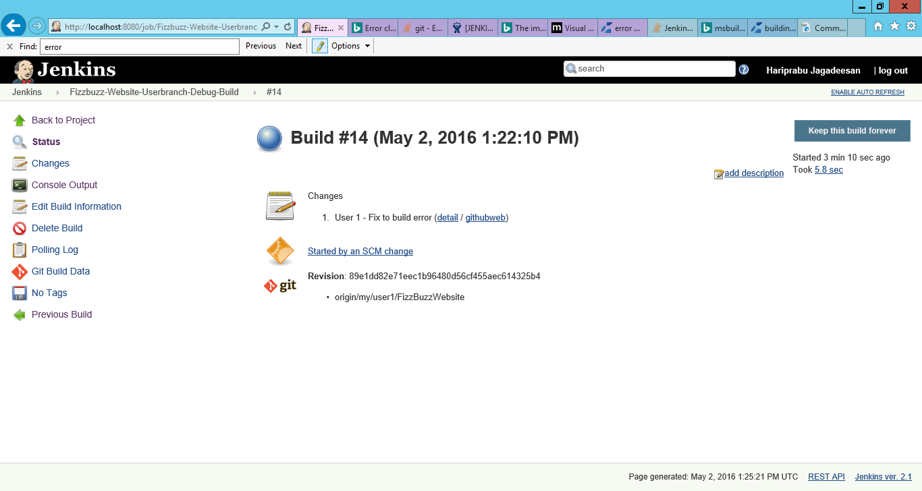

**Fizzbuzz-Website-Featurebranch-Release-Build**

This will build the project branch once any change is merged into the standard project branch to check for any integration issues.

**Job Configuration**

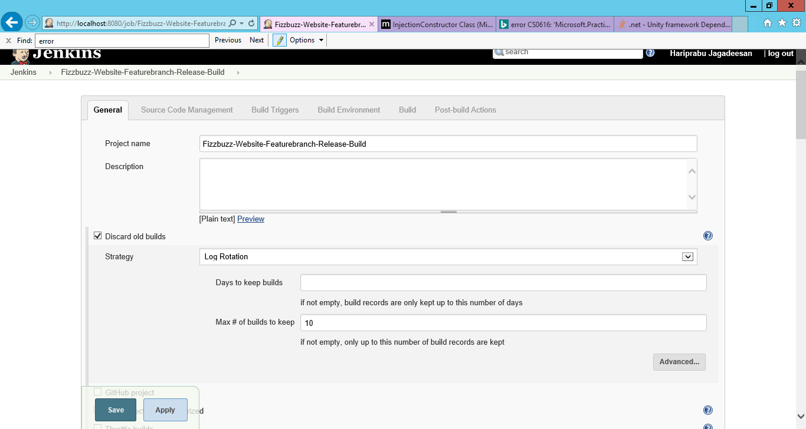

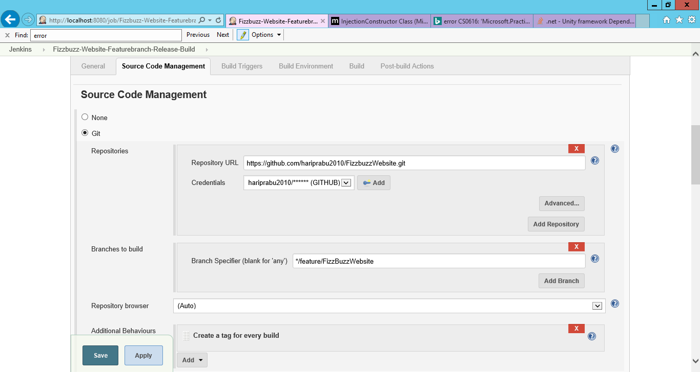

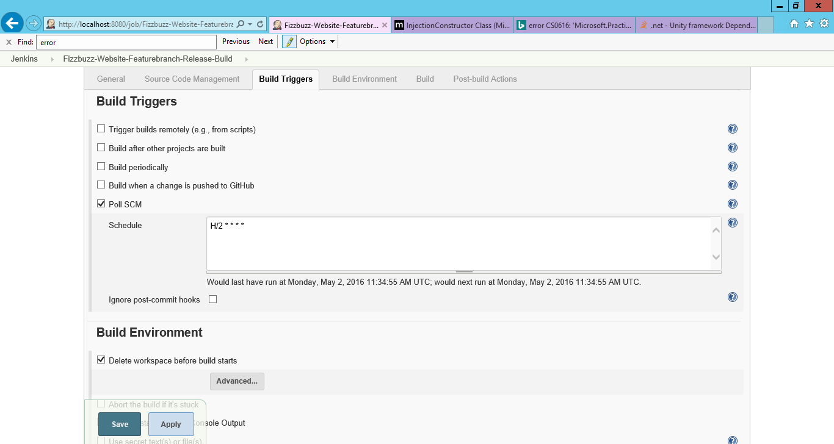

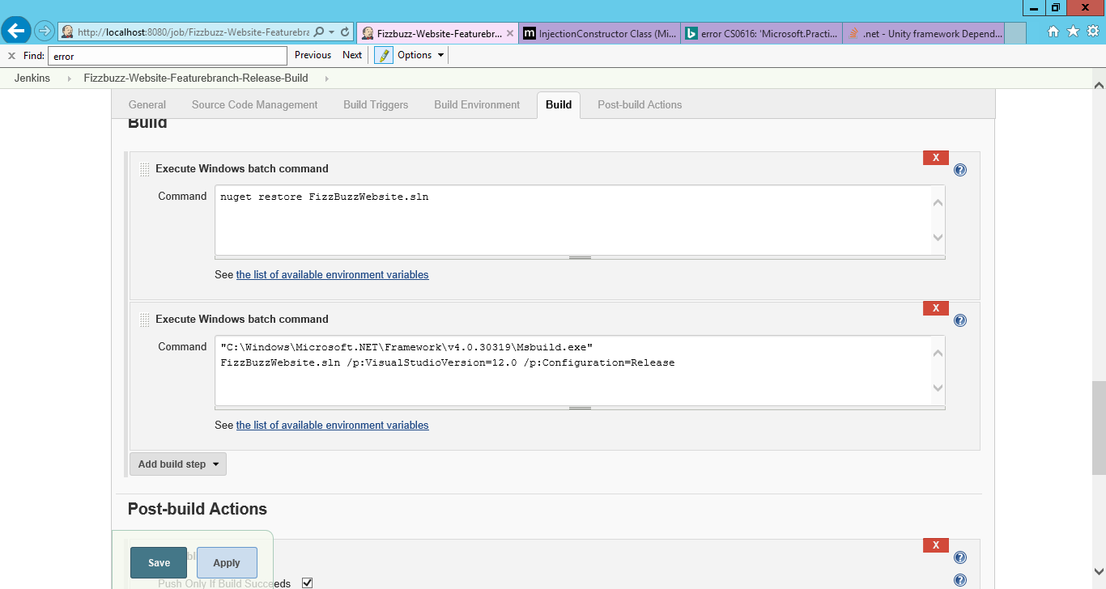

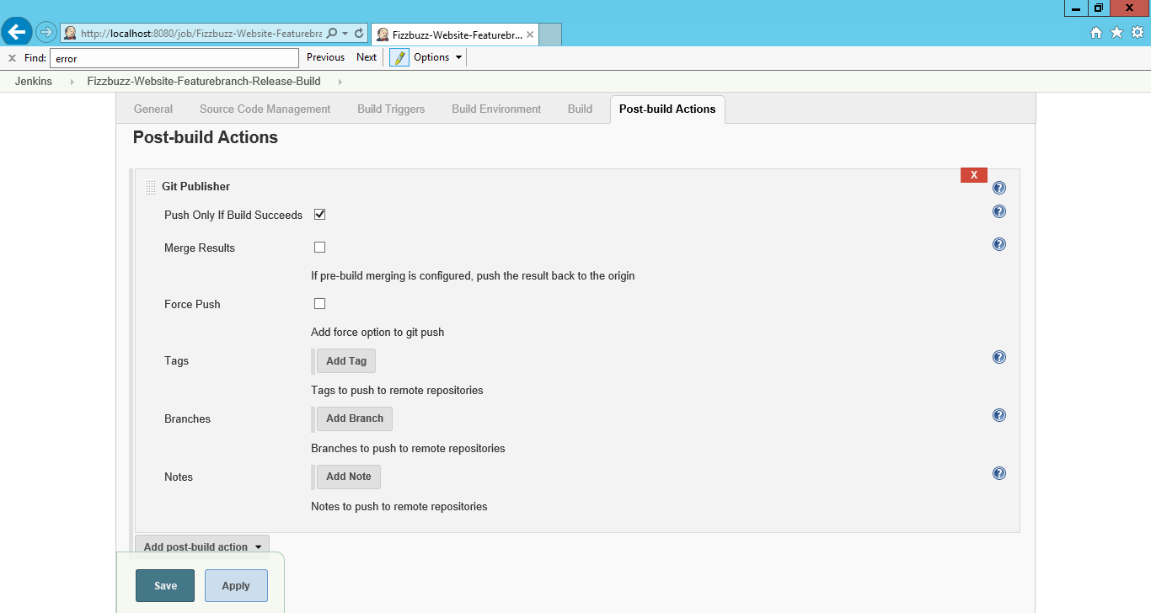

GIT polling log for Feature branch

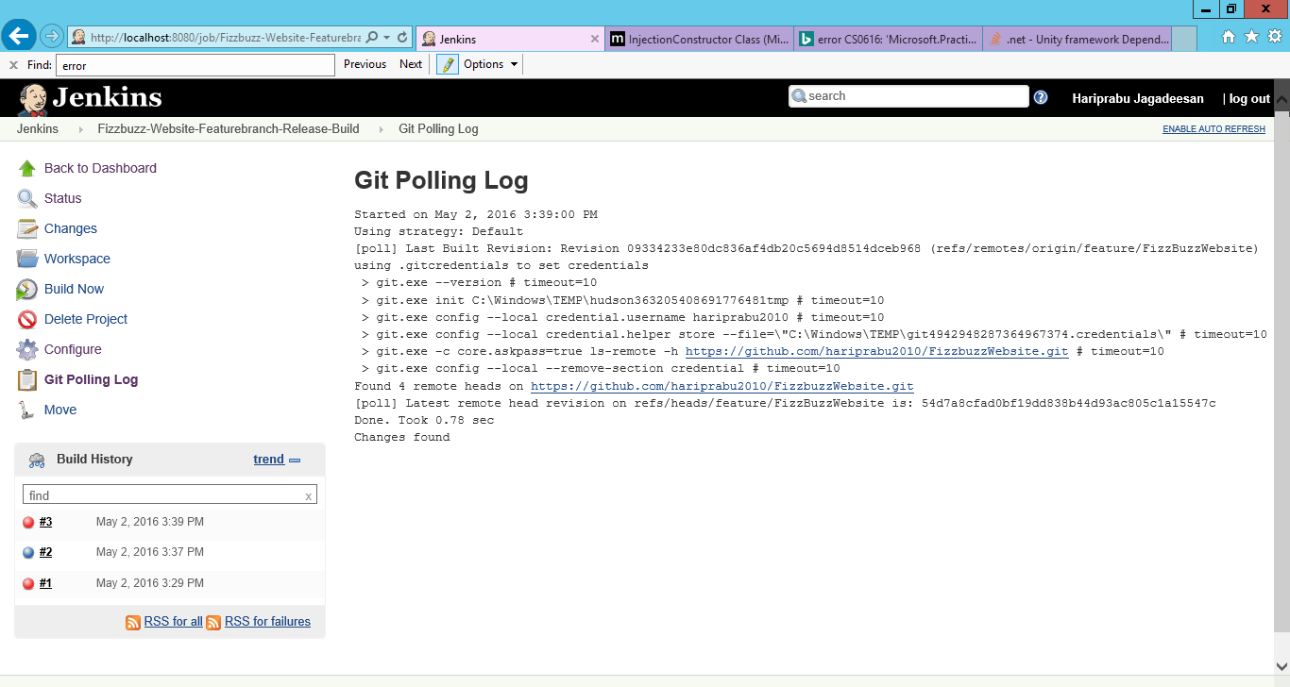

Build Status for Feature branch

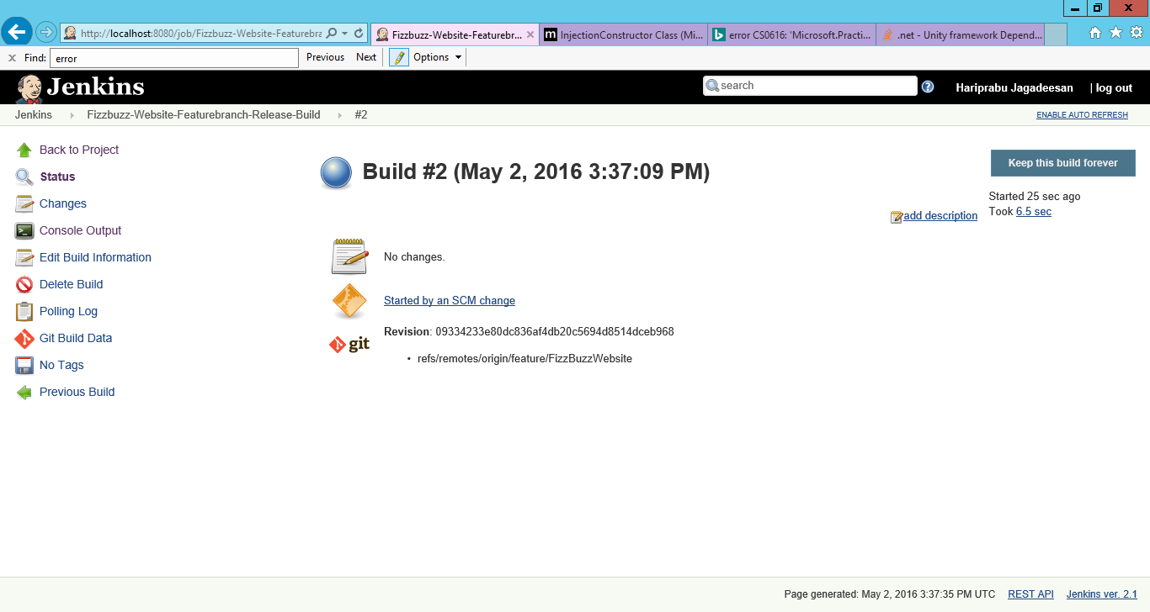

This could further be extended into a pipeline with Unit Testing jobs, Code Quality Analysis, Automated regression tests, automated performance tests and then deployment into Production. But considering the scope of the exercise (CI), I have not configured those jobs.